File permissions in Linux

Project description
In this project, I acted as a security professional responsible for auditing and managing file system authorizations for a research team. I used Linux commands to identify insecure permission settings, remove unauthorized access, and ensure that hidden files and directories adhered to organizational security policies.

Check file and directory details
To check the permissions of all files and subdirectories—including hidden files—within the /home/researcher2/projects directory, I used the following command:
ls -la

Current Permissions
Based on the provided file structure, here are the current permissions represented:
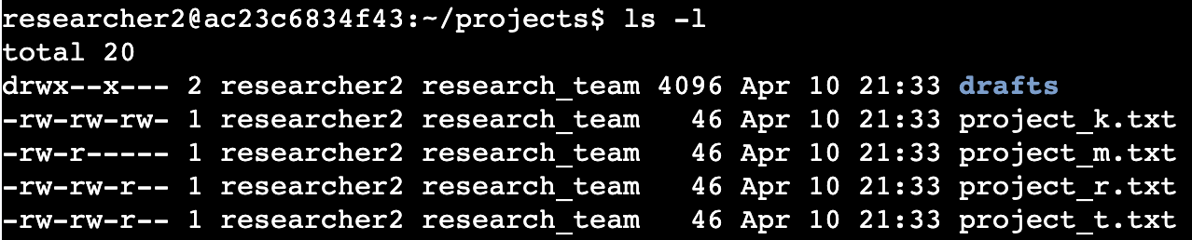

Describe the permissions string
Using project_t.txt (-rw-rw-r--) as an example, here is a breakdown of the 10-character string:
- 1st Character: Represents the file type. A hyphen (-) indicates a regular file, while a d indicates a directory.
- Characters 2–4: Represent the User (owner) permissions. rw- means the owner has read and write access, but not execute.
- Characters 5–7: Represent the Group permissions. rw- means members of the group have read and write access.
- Characters 8–10: Represent the Other permissions. r-- means all other users only have read access.

Change file permissions
The organization prohibits "Others" from having write access to any files. project_k.txt currently has rw- for "Other" (-rw-rw-rw-). To remove write access for others while maintaining read access, I used:
chmod o-w project_k.txt
Updated permissions: -rw-rw-r--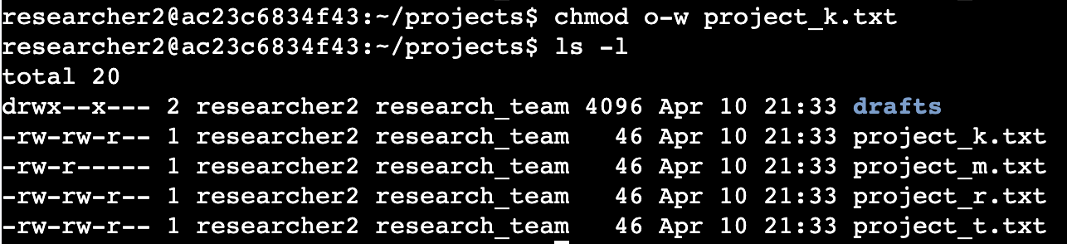

Change file permissions on a hidden file
The archived hidden file .project_x.txt currently allows the group to write but not read. It needs to be modified so that the User and Group have read access only, and no one has write access. I used:
chmod u-w,g-w,g+r .project_x.txt (Alternatively: chmod 440 .project_x.txt)
Updated permissions: -r--r-----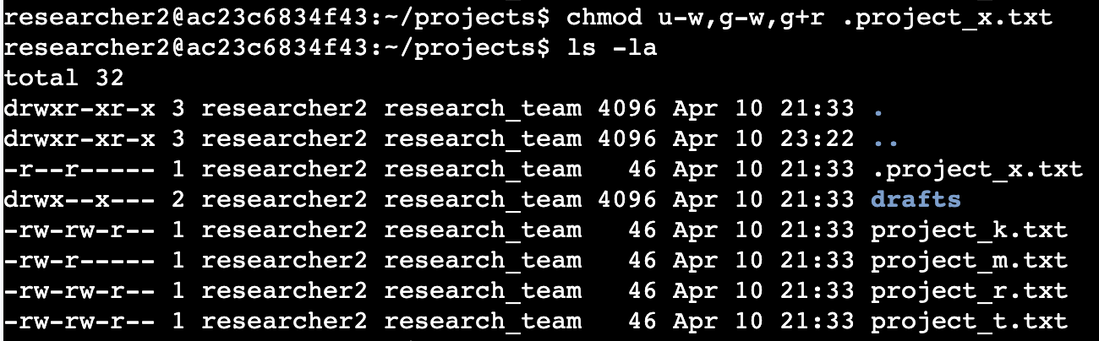

Change directory permissions
Only the user researcher2 should have access to the drafts directory. Currently, the group has execute (--x) permissions. To remove all access for the Group and Others, I used:
chmod g-x,o-null drafts (Alternatively: chmod 700 drafts)
Updated permissions: drwx------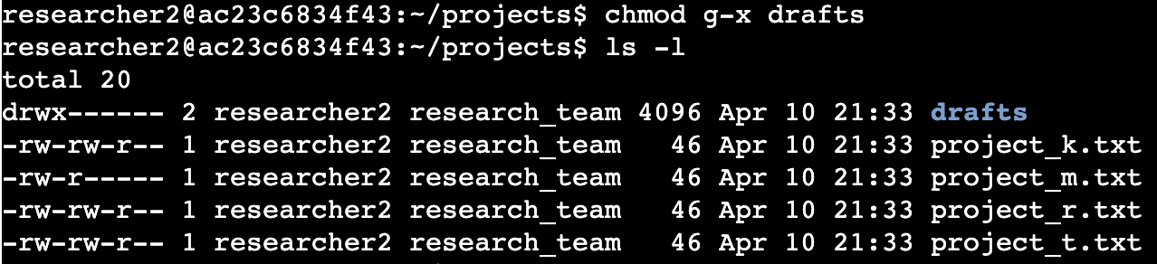

Summary
Through this task, I audited the file system using ls -la to uncover hidden files and existing permission vulnerabilities. I then applied the chmod command to enforce the principle of least privilege, specifically removing write access for unauthorized users and securing sensitive research directories. These actions ensure that organizational data remains confidential and protected from unauthorized modification.

